STAFF REPORT TO COUNCIL Report No. 37-2022

Date: March 21, 2022

From: Matthew Armstrong, Chief Administrative Officer and Treasurer

RE: 2022 Operating Budget
____________________________________________________________________

Recommendation:

That Council approved the 2022 Operating Budget with total revenues and expenditures of $10,042,035, and

That Council approve the 2022 Water and Wastewater Budget with total revenues and expenditures of $2,939,397, and

That Council approve that the final property tax payment for 2022 shall be split into two equal payments due August 31, 2022 and October 31, 2022.

Background / Analysis:

The 2022 Budget has been reviewed over several meetings.

December 6th Timelines, Revenue and Expense Assumptions, Property Tax Information and Targets

December 13th Health Services & Social Services

January 4th Administration, Protective Services, Planning & Development

January 17th Transportation, Parks, Recreation

February 7th Environmental Services, Water and Wastewater, Ec Dec & Tourism

February 22nd Revenue & Taxation

March 7th Operational Budget Review and Alignment with Strategic Plan and Service Delivery Review

At the December 6th Council meeting the revenue and expense information and assumptions were reviewed from a high-level perspective. It was discussed that a property tax increase of two to three percent inclusive of the one percent dedicated to infrastructure would be the target given the revenue and expense pressures being faced in 2022.

The budget operating includes a property tax increase of 2.85% inclusive of the 1% dedicated to the infrastructure reserve.

This budget includes a 2% increase in water and wastewater rates effective July 1, 2022.

The table below illustrates the effect on the median property in each category of the 2.85% tax levy increase and the decrease to the educational tax rates for commercial and industrial properties.

Financial Implications:

The following table captures the 2022 Operating Budget status excluding projects.

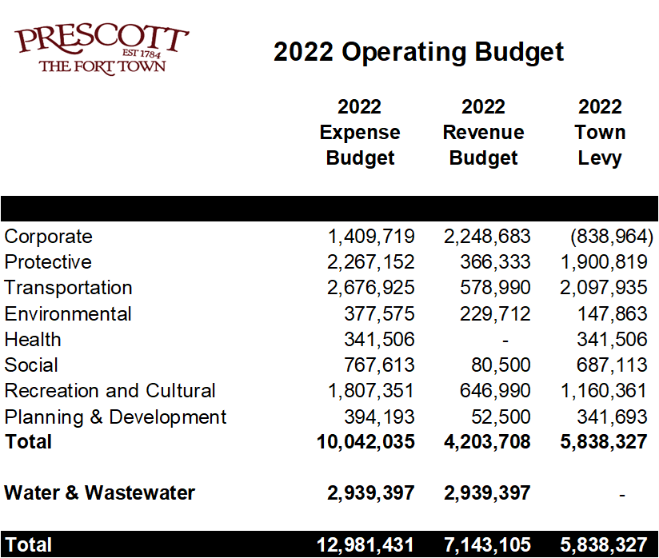

As noted above, the 2022 Operating Budget includes a 2.85% property tax levy increase. The educational tax rates for 2022 remain the same as 2021. This results in an overall property tax increase of 2.44%.

The 2022 Operating Budget includes a net contribution to reserves of $1,082,964 before capital and operational projects are considered. The water and wastewater budgets include a net contribution to reserves of $528,352.

The table below shows the effects of the change on each tax class.

Environmental Implications:

None

Attachments:

None

Submitted by:

Matthew Armstrong
Chief Administrative Officer & Treasurer

